**Kentico**

**Resetting your password on the Front - End**

**INTRODUCTION**

This document is to help walk you through the process of resetting your password on the front-end of the site.

This Method should only be used after trying the normal way of resetting your password and it fails.

Any issues encountered during registration can be sent to [helpdesk@pacounties.org](mailto:helpdesk@pacounties.org).

**Admin Documentation**

1. View Customer Request, stating something along the lines of password reset failing.
2. Login to the CMS side of your site and go to the Users application which should look like.

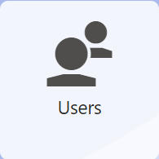

1. Once here select the green pencil icon on the user you wish to change the password for, and you should see the following.

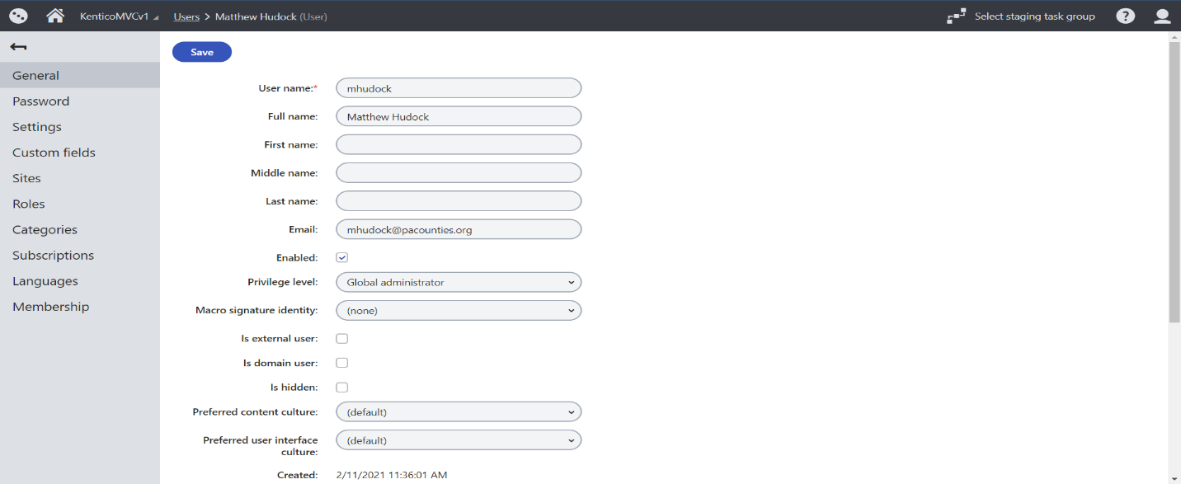

1. On the **Left Side** select the **Password** Option and you should see.

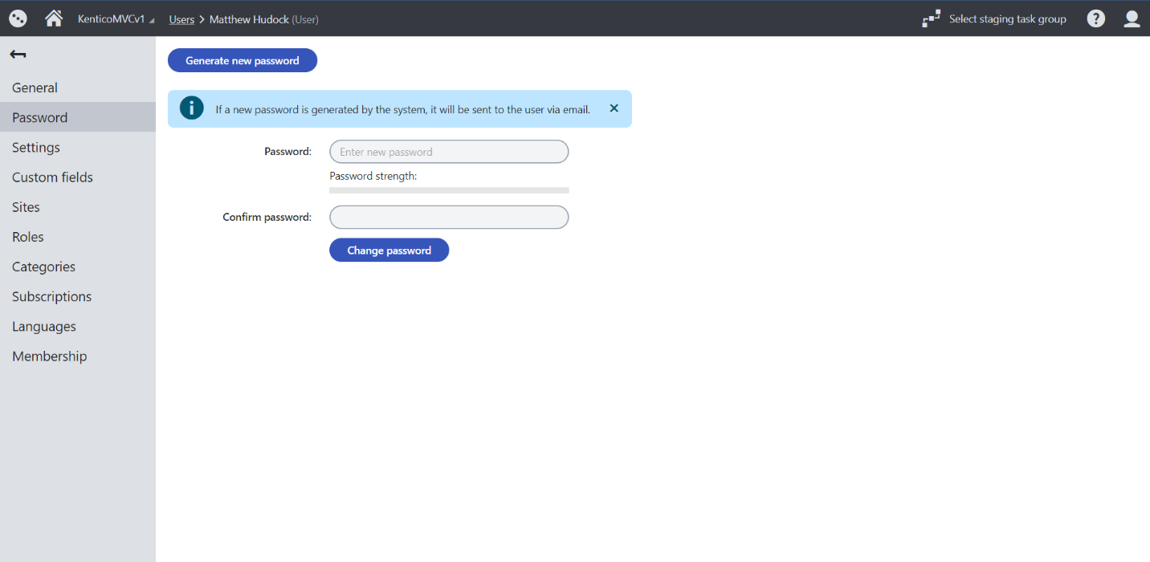

1. Enter what you wish to be the temporary password for this user, in this case I will just use Password123! You will need to enter this in both the **Password** field and **Confirm Password** field. Once you have entered select **Change Password**. You should then see

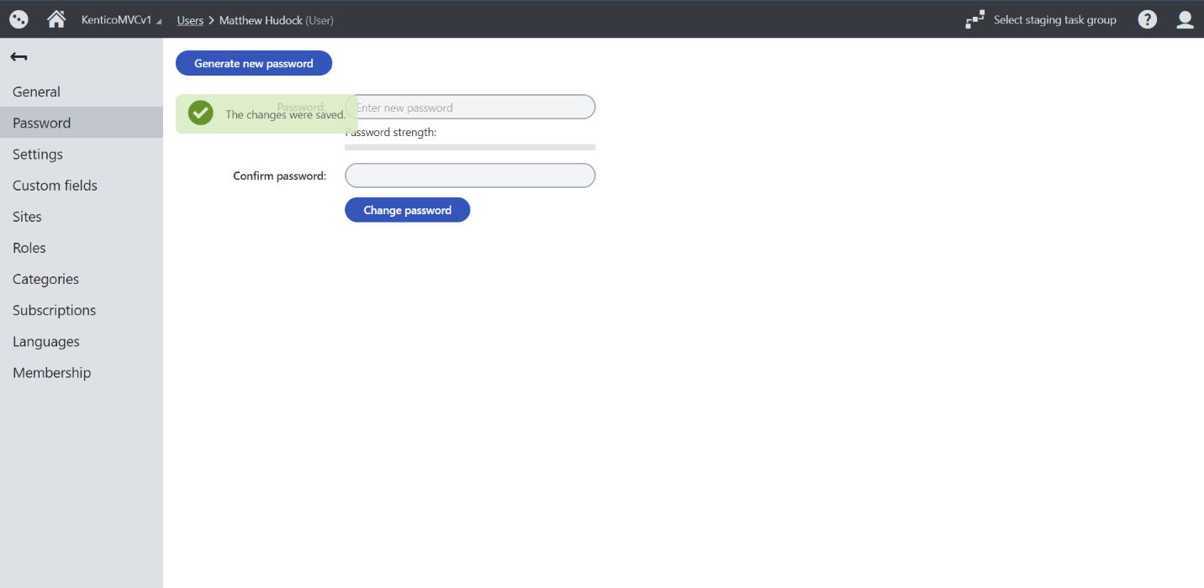

1. Once the user’s password has been updated, report back to the user that was having issues and provide them with the Password you updated their account to have.

**Front-End User**

1. Once you receive a communication stating your password has been updated temporarily you will need to navigate too the site you are requesting access too and go to the login portion. Once here you should see a screen like.

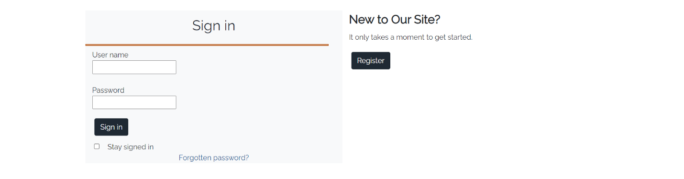

1. Once here you should login with your username that you created when you registered, and the temporary password that was assigned to you via the above communication. Once you do so you should be taken to the home screen of the site and see the following in the **Top Right Corner**

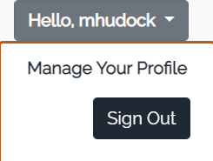

1. The Hello Portion should say your username i.e. Hello,UserName. Once hovering over that field, you should see the **Manage Your Profile** Option Click on that option and you should see the following.

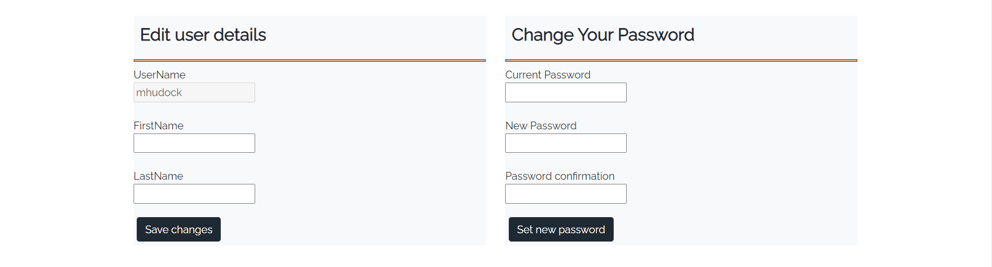

1. Under the **Change Your Password** Section of this page you are going to want to fill out the following information.
   1. **Current Password** – Password Provided to you in the above communication.
   2. **New Password** – whatever you want your new password to be
   3. **Password Confirmation** – Confirming what you entered in New Password
2. NOTE: There may be a password policy in place here is a good guidance practice for Passwords

**Password**

The password should be 10 characters with at least 1 being a special character (iE: %, !, #, etc.)

6. Once you have done the following select the **Set New Password** Button, and you should see the following screen.



1. Once you have saw this screen your password should be updated to what you changed it to in the previous steps, it will not log you out of your current session, so when logging in next time you will need to enter that newly created password to log back in.